EX NO: 8POWER SPECTRAL DENSITY (PSD) ANALYSIS OF PHASE MODULATED (PM) SIGNALS USING MATLAB
NAME:V.RUSHMITHA
DATE: 08/10/2026
Objectives
i) To generate a Phase Modulated (PM) signal in MATLAB using specified carrier and message
signal parameters.
ii) To compute the frequency spectrum of the PM signal using the Fast Fourier Transform (FFT).
iii) To calculate and plot the Power Spectral Density (PSD) of the PM signal using MATLAB.
iv) To identify the carrier component and sideband frequencies present in the PM spectrum.
v) To analyze the effect of phase modulation on the spectral distribution and bandwidth of the
transmitted signal.
vi)To investigate the influence of modulation index on the Power Spectral Density characteristics
of the PM signal.
Procedure:
1. Open MATLAB and create a new script file.
2. Initialize the MATLAB workspace by clearing all variables, command window contents,
and open figure windows using:
clc; clear; close all;
3. Define the message signal amplitude (AmA_mAm), message frequency (fmf_mfm),
carrier amplitude (AcA_cAc), carrier frequency (fcf_cfc), sampling frequency (fsf_sfs),
and phase sensitivity constant (kpk_pkp).
4. Generate the time vector required for simulation.
5. Generate the message signal and carrier signal.
6. Generate the Phase Modulated (PM) signal using the PM equation.
7. Compute the Fast Fourier Transform (FFT) of the PM signal.
8. Calculate the Power Spectral Density (PSD) from the FFT results.
9. Generate the frequency axis corresponding to the FFT output.
10. Plot the message signal, PM signal, frequency spectrum, and PSD using MATLAB
plotting commands.
11. Determine the carrier frequency component and sideband frequencies from the spectrum.
12. Display the phase deviation and estimated bandwidth using the MATLAB Command
Window.
13. Analyze the PSD plot and observe the spectral distribution around the carrier frequency.
14. Record the observations and verify the characteristics of Phase Modulation in the
frequency domain.
PROGRAM (MATLAB CODE)
clc;
clear;
close all;
% Parameters
Am = 1; % Message Amplitude (V)
fm = 100; % Message Frequency (Hz)
Ac = 5; % Carrier Amplitude (V)
fc = 1000; % Carrier Frequency (Hz)
fs = 20*fc; % Sampling Frequency (Hz)
kp = pi/2; % Phase Sensitivity (rad/V)
% Time Vector
t = 0:1/fs:4/fm;
% Message Signal
m = Am*sin(2*pi*fm*t);
% PM Signal
pm = Ac*cos(2*pi*fc*t + kp*m);
% Phase Deviation
beta = kp*Am;
% FFT
N = length(pm);
f = linspace(-fs/2,fs/2,N);
PM_FFT = abs(fftshift(fft(pm)))/N;
% Power Spectral Density
PSD = (abs(fftshift(fft(pm))).^2)/(N*fs);
% Approximate Bandwidth
BW = 2*(beta+1)*fm;
fprintf('Phase Deviation = %.2f radians\n',beta);
fprintf('Estimated Bandwidth = %.2f Hz\n',BW);
% Plotting
figure('Name','PSD Analysis of PM Signal','NumberTitle','off');
subplot(2,2,1);
plot(t,m);
title('Message Signal');
xlabel('Time (s)');
ylabel('Amplitude');
grid on;
subplot(2,2,2);
plot(t,pm);
title('Phase Modulated Signal'); xlabel('Time (s)');
ylabel('Amplitude');
grid on;
subplot(2,2,3);
plot(f,PM_FFT);
title('Frequency Spectrum of PM Signal');
xlabel('Frequency (Hz)');
ylabel('Magnitude');
grid on;
subplot(2,2,4);
plot(f,PSD);
title('Power Spectral Density');
xlabel('Frequency (Hz)');
ylabel('PSD');
grid on;
OUTPUT (GRAPH)
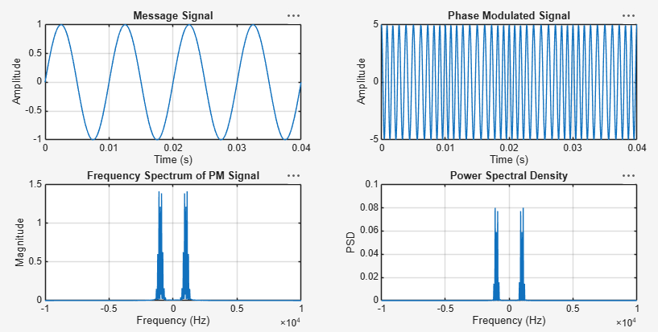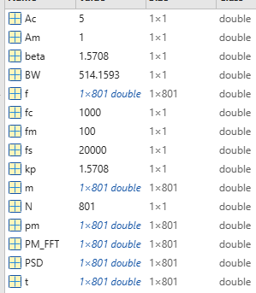
Example: (just for Understanding)
Given
· RESULT
The Power Spectral Density (PSD) of the Phase Modulated (PM) signal was
successfully obtained and analyzed using MATLAB.
i) Message Frequency = 100 Hz
ii) Carrier Frequency = 1000 Hz
iii) Phase Deviation = 1.57 radians
iv) PM Modulation Index = 1.57
v) Estimated Bandwidth = 514 Hz
vi) The PSD plot showed the carrier component and multiple sidebands around
the carrier frequency, confirming the frequency-domain characteristics of Phase
Modulation.

